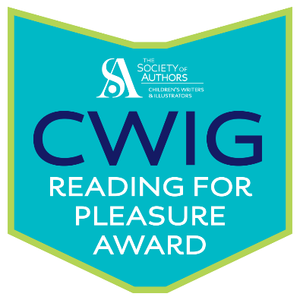

READING FOR PLEASURE AWARD

AUTHOR CHECKLIST

Please complete and email this form to Teddy McDonald at:

cwig@societyofauthors.org

**Author details:**

Name:

Email address:

Twitter handle (if applicable):

Postal address of school or schools:

School contact email address:

School Twitter handle (if applicable):

Name of headteacher:

Names and roles of other contacts (including booking contact, literacy coordinator, librarian, and any other staff members involved in your visit):

Date of visit or visits:

Citation as to why this school is exceptional (no more than 150 words – this will be given to the school and potentially published).

Optional: a short paragraph with your personal reasons as to why you are nominating the school. We may pull quotes from this for publicity.

Optional: attach high-quality photographs or images from your visit (e.g. artwork made in class). These images will only be used non-commercially to publicise the award and if they feature pupils must have permission from the school. Please provide descriptive captions and the name of the creator of the image.