|  |  |
| --- | --- |
| *The Tomato and the Puddle…the very 1st article submitted to this magazine by a member of the Group.*  READER MAGAZINE An Occasional Publication of the Writers as Carers Group. *“You don’t have to stop being a writer if you start being a Carer.”*  December 2018 Issue 1. | We Care────We write────But not always at the same time────Sometimes we don’t get to write much────If anything_____But we’re still writers The WaC Group is there for any SoA member who finds that their role as carer could do with a bit of help and support from other writers who are or have been in the same boat. |

Editorial

## Rampaging T-Rex*Books only exist because of writers, everyone else feeds off their output without which the whole thing goes phutt.  That should make writers the almighty ones of any sort of publishing world shouldn’t it?*

**Am I alone in thinking…?**

…that the world of publishing is something of a dinosaur.  There are a few mighty T. Rex ones, a few big herbivores and lots and lots of mid and little-sized ones, but all of them are bound for extinction. Not that I think physical books will die but they’ll change their status and go back to what they once were, treasured possessions that are bought to be read, kept and re-read, an elitist thing for the educated, the discerning and the wealthy.  At least those like what I write will be.

## *In the Great Change when Bloomsbury and Harper Collins and Hachette and all the other mighty dodos disappear…*

You see, the meteor has struck, the dust cloud is rising and the cold-blooded publishers are increasingly being denied the financial warmth in which they need to bask to stay alive.  They’re dying but they haven’t lain down yet.  And the meteor?  The internet of course.  And what will replace the publishers, the agents and all those who have for so long fed off the industry?  A virtual world.  A world where, online, anyone can be a publisher, anyone can be an agent, anyone can set up as a bookseller and anyone can be a writer.  Why not?  All you need is a vehicle, a social media site, where you can register as a publisher and put up your submissions guidelines and wait for the stuff to roll in by e-mail.  Be an agent.  Put up your shingle and ask for clients to e-mail you their first three chapters with a brief synopsis and an even briefer CV.  Be a bookseller.  Do deals with the virtual publishers, take the ms they have accepted and knocked into e-book format using, of course, someone who has set up as a book designer.  Have a display of the titles you carry, offer discounts, do three-for-two deals.  The ones you won’t find in this virtual publishing world will be the printers, the warehousing and distribution people and anyone else who depends on having a physical book which needs to get made and sent from one place to another.  They carry on, but they deal in other things, physical things, jam and bread, hats and underpants, shoes and sealing wax.  But not, to any great extent at least, books.

And the writers?

Books only exist because of writers, everyone else feeds off their output without which the whole thing goes phutt.  That should make writers the almighty ones of any sort of publishing world, virtual or physical, shouldn’t it?  But it doesn’t, because there are so many of us.  A few, by God knows what system of luck, fate, fashion, talent or whatever, become mega-stars for a time.  But most of us struggle along as best we can knowing that there are hundreds, thousands, no one knows how many, out there waiting, hungry to take the humble place we occupy in literature.

So, in my virtual world, nothing essential will change for those who write.  Writers of all sorts will submit.  Publishers will sort, select and reject.  Agents will make connections and do deals.  Booksellers will buy and sell.  And the whole merry-go-round will carry on much as before, except for the mighty offices of glass and steel, the obscene salaries of senior execs., the cosy dinner parties and the drinkies and all the rest of the arrogant froth that sits on top of the talent which drives the whole fruit-cake of our mixed-metaphor industry.  Writers will go on sitting alone, writing.  They will search for publishers or agents and submit.  They will get rejection slips from the courteous and be ignored by the boorish.  For the writer very little will become so very different the virtual world from things as they are now, except for the six free copies on the bookshelf.

In the Great Change when Bloomsbury and Harper Collins and Hachette and all the other mighty dodos disappear, little writers will survive and scurry about and wait for the next Leviathans of publishing to emerge from the virtual sea in which they were created.  All we need is someone with the vision to create that sea, that social media site which will welcome all and everyone to be what they choose in the world of virtual publishing.

But I *will* miss the six free copies when that glorious day comes, yes, I will.

**James Green**

**THE TOMATO AND THE PUDDLE**





[This Photo](http://moblog.net/view/852648/puddles-of-cloud-and-stone) by Unknown Author is licensed under [CC BY](https://creativecommons.org/licenses/by/3.0/)

***“Everyone passes a thousand story ideas a day. Good writers see five or six.”***

by

**Stephen Jansen**

*"It really is a question of finding the most suitable order for releasing information to the audience and not feeling any responsibility to do it chronologically, just like we don't in life."* - Christopher Nolan

i

‘There’s a title for something,’ I thought, as people exhaled vape smoke and passed the tomato in the puddle near the edge of the pavement, unsure if they’d seen a piece of street art. I have an advantage. I saw a delivery driver unload a split box of tomatoes, the artist at work. If you want to write, you need to look around.

I have two favourite quotes about writing.

*“Writing is easy. All you do is stare at blank sheets of paper until drops of blood appear on your forehead.”*

I’m grateful I didn’t see that at the start of my writing endeavours. I prefer this quote, *“Everyone passes a thousand story ideas a day. Good writers see five or six.”*

That brings me back to tomatoes and puddles. The combination of those two items engaged the attention of curious pedestrians; the difference is the writer remembers and uses it. People forget and continue shopping. Nothing wrong with that. Maybe they’re neurosurgeons or stock analysts. Puddles and tomatoes fall off their radar. If you’re a writer, or planning to be a writer, puddles and tomatoes are your business, because tomatoes in puddles become guns in hedgerows, aliens in shell-suits, time travellers in clock shops, demons in churches, spies on army bases or rock stars in hospitals. The question a writer must ask is, ‘how did that happen?’ Pick any of the above. Make some of your own. It’s fun. Who owned the gun? (tomato, stolen car, time machine, runaway train…) who owned the hedgerow or the puddle? If it isn’t a coincidence you’re on your way to a story. If it is a coincidence you’re on your way to a novel, or maybe a screenplay.

ii

I grew up in the days when books represented the most popular and best examples of science fiction. It’s hard to imagine or remember, but before 1977 and the first Star Wars film (now called Pt IV: A New Hope, and slotted in the franchise for continuity), there were only about six credible science fiction films around. The classics such as the original versions of War of the Worlds, Day of the Triffids, the Fifties, Sixties and Seventies atomic bomb paranoia offerings, but for me they were, Planet of the Apes (1969), 2001: A Space Odyssey (1968), Silent Running (1972), Dark Star (1974), Solaris (1971), THX1138 (1971), and Logan’s Run (1976).

Everything else fell into realm of the hubcap spacecraft B movie. (The Terrornaughts is one of the worst examples. I sat through it so you don’t have to). To be a fan of the genre in those days was to live in exile, but I devoured science fiction like a whale through plankton until a high school teacher asked if I read anything else. I told him that I didn’t, so he gave me a copy of George Orwell’s 1984 and told me this book had a science fiction premise. It didn’t read like a science fiction novel. It depicted a brutal dystopia, and as time passed, became familiar. I read Orwell’s books; The Road to Wigan Pier, Homage to Catalonia, but Down and Out in Paris and London revealed characters released from imaginary worlds, walking around like you and I. They had been there all the time of course in metaphors like Do Androids Dream of Electric Sheep (Blade Runner). I just hadn’t consciously noticed. The universe of books exploded like the big bang, my choices based on how different they were from the last one. Lust for Life by Irving Stone crossed over to Brett Easton Ellis’ Less Than Zero, Thomas Wolfe’s The Bonfire of the Vanities to Hunter S Thompson’s Fear and Loathing in Las Vegas to Ballard’s Crash and the complete works of William Burroughs and Jack Kerouac with Charles Dickens. These writers were incapable of living their lives any other way. Their books were uncontrollable side effects. Michael Moorcock’s career followed two paths. The sword and sorcery novels of Elric and the literary fiction of Mother London. I liked these people. They were the right kind of crazy.

iii

Guitar players will tell you that everything they hear comes out in how they play before individual style develops. There’s writing a novel for pleasure and writing one that makes a difference, if only to you. I wrote what I liked and had fun. It was just as satisfying in alien territory, writing about situations that bothered or fascinated me. I learned to accommodate writer’s block when I read a sound piece of advice. *“If you suffer from writer’s block, you don’t have enough information.”* That’s priceless. Read around the subject matter. You need to cover read at least three times as much as you need in order to put your voice into something alien to you. Write what you know and stay happy or be Henri Charier (Papillion) and write what happened. Eventually the ‘big’ theme will keep you awake at night. That’s when you’re hooked.

iv

I learned that certain science fiction writers didn’t like the genre or didn’t read it at all. They used the form because it fit their stories and allowed them to exist in places unhindered by reality. Alfred Bester’s ‘The Stars My Destination’ is ‘The Count of Monty Cristo’ in space. Check out ‘Death is no Obstacle,’ Moorcock’s book/interview with Colin Greenland. It’s a gold mine of structure and technique.

v

How does it work?

This is not a template or guide, it’s how it works for me. I always know the ending, up to a point, I know where I’m going. I have direction. I have structure but no locked- down pathway of plot. Better to let the story run. Sometimes it breaks free and that’s the best, when it’s flying. But you have to prepare for a landing at the end of the ride.

vi

There are times when it’s good not to read or write. Let the plot sink in. Many authors recommend a walk. Your subconscious works even if you don’t. Enjoy the process and the journey. If you’re punishing yourself, the readers will notice. You have to love writing or you will stop and find something else. It’s a discipline that doesn’t come easy. When I started out, many years ago, I’d start to write, a few hours passed and the pizza in the fridge called to me. But the writing was rolling so I’d persist until coffee joined the desire/reward queue as justification for the work I’m doing. Four hours later the hunger and tiredness wins and I eat pizza and drink coffee. Then I relax and watch TV for an hour before I go back to writing but the phone rings and it’s a friend of mine who just got back into town and we meet in the pub, but I can still write later. In the pub, more friends arrive and a ‘putting the world to rights’ session begins fuelled by more drinks and the pub’s menu. Then everything goes black and I wake up on the beach the following afternoon. Point being, get a good writing day in. Four hours is good. Then go have fun. Whatever your definition of fun is.

vii

Commercial break: A note on freelancing

My first freelance job had a ‘style test’ before the client awarded the project. I had to convert a section of screenplay to a novel. The sample piece was a crime thriller. I passed the test and the client awarded me the work. When it arrived, to my horror, the script’s only reference to a crime thriller was contained in the test pages. It was actually a script about Hip Hop DJ’s in Nineteen Eighties New York. I knew as much about Hip Hop as I do about neurosurgery. I know what it is, just don’t ask me to perform brain surgery. Earlier I mentioned the cure for writer’s block and I needed it now. After a week watching ‘Pimp My Ride’ I had the slang as second nature. I managed to write the novel from the client’s script and got paid. The lesson here, apart from make sure you know what you’re getting into, is if something freelance appeals to you then try it, but it’s not a good idea to leave your comfort zone with someone else’s money unless you are confident and skilled.

To close this section, here are a few tips and general pointers I find useful…

1. Read everything. And I mean, *everything!*
2. Step out of the zone every so often and write something out of your genre.
3. Adopt a Dr. Frankenstein attitude to books and films. Take them apart and rebuild them to see how they work.
4. Stay off the internet. Social media will be there when you’re done.
5. Show don’t tell.
6. Make sure your characters change. For better or worse and back again.
7. Keep a note book.
8. Try to find a good proof reader.
9. Never give up.

viii

Screenplays: Front row with pop corn

*“I’ve always been interested in people who feel uncomfortable in their own skin, and they want out. And the ways that one gets out are sex, violence, religion and art.”*

*Paul Schrader*

One Sunday evening I’d zoned out before the TV with plans for an early night when an arts programme called The South Bank Show wandered onto Channel Three and proceeded to change my approach. The show featured a screenwriter named Paul Schrader; the man who wrote an industry transforming and disturbing screenplay called Taxi Driver. I sat stunned. My mouth hung open. The movie, I learned, came from Schrader’s experience of having nowhere to live at a certain point in his life. He found himself in New York, driving around and living in his car. When he had to go to the emergency room with stomach pains, he realized that the nurse at the hospital was the first person he had spoken to for three weeks. I felt a sharp, existentialist jab to my ribs. I bought Syd Field’s ‘Screenplay.’ A week later I was on my way to a first draft.



[This Photo](http://scientificgardener.blogspot.com/2013/05/eureka.html) by Unknown Author is licensed under [CC BY-NC](https://creativecommons.org/licenses/by-nc/3.0/)

ix

Returning to Tomatoes and Puddles for a moment; this happened right in front of me in a second-hand goods store buying props for a theatre company. (Long story. Another time?) I needed three or four old phone handsets and I was looking around when a man came into the store ranting that his house had been robbed and his phone was for sale in the shop and he wanted it back. The store’s manager took the phone off sale and told the guy to call the police who would give him a crime number and look into the matter. Ten minutes later a police officer arrived and recognized the guy from last Saturday’s football match where he allegedly threw a brick at the officer. The man was marched out of the shop, minus his stolen phone. A one act play, right in front of me. Embellish what you see. Take it to the extreme. There is no point in characters who ‘might be interested in reaching their goal.’ He or she has *got* to reach the goal because their life depends on it. Somewhere there’s a screenwriter who will write about a puddle and a tomato (or has already). I wish that writer good luck, because it’s not enough to have two elements and hope a story will rise up to meet the pages. There is the matter of theme. Theme tells the audience what the story is about. This is different to what happens. Here is my favorite example…

What happens: ‘In the movie Jaws, a killer shark threatens to destroy the livelihood of a coastal town when it chooses its feeding ground off-shore.

The film is about, (on one level) ‘a man (Chief Brody), overcoming his fear of the ocean.’

It’s not immediately obvious, but that’s good. The audience will enjoy finding out.

***Be a ruthless editor of your own work. If you love a scene, but it doesn’t fit, you have to kill it.***

x

“I want to play a game,” said a character named Jigsaw. (Saw). Here is a game I used to play. Find three magazines that have reader’s letters pages. Tear out the pages, (please buy the magazines first) and place them edge to edge on a table and then pick three reader’s letters at random. Write them into stories, then mix them up. Make characters and situations collide. Sometimes a real monster emerges. Then you can take it to the extreme if you need to, but please change the names. An example of this that borders on genius is Psycho (1960) (Alfred Hitchcock). A third of the way in you realize you’re watching the wrong film. This occurs when Marion Crane is murdered by Norman Bates, ignorant of the stolen forty thousand dollars that Norman throws into the car with the body to bury in the local swamp. Jump forward three decades and watch Quentin Tarantino use the pedestrian crossing scene in Pulp Fiction where Marion Crane sees her boss after telling him she was going home after depositing the forty thousand at the bank. (which she has not done). The scene is reproduced when Bruce Willis, having retrieved his watch from his apartment, stops at a red light. Marcellus Wallace walks in front of the car carrying a pizza. On recognizing Bruce Willis, he lets out an expletive that was clearly visible on Marion’s boss’ face, but due to the censorship of the day remained a silent expression. The same amount of money is at stake in both segments of the film, handed to Bruce Willis in an envelope similar to Marion Crane’s. It’s interesting to see the melting pot screenwriters have at their disposal, and the endless people watching, life watching and movie watching required to achieve this level.

Some advice…

1. Be a ruthless editor of your own work. If you love a scene, but it doesn’t fit, you have to kill it.
2. Finish your first draft to the end. Then edit, not halfway through.
3. See some good movies and be inspired by them. See just as many bad ones and see why they don’t work.

xi

It’s been a serious chapter so I’ll end on a funny story. This is the reason I love words and how they change meanings and actions. This story was told by Peter Sellers on a chat show…

“I got a letter from this chap, who was obviously a fan of the films and everything, and he’d written and asked for a *singed* photograph of me. I took my lighter and partially burned one of my publicity pictures. Then I posted it to him. About a week later I got a second letter from the same bloke and he’s written, “thanks for the photograph, please could I have another, as the one I received was *signed* around the edges. Poor man had gone through his life with the N and the G the wrong way around.”

Priceless, you can’t make that up.

xii

And why not?

The Beatles were told that guitar bands were going out of fashion, Cold Play that their music wasn’t commercial. David Bowie’s first manager was told to, “get that long haired git out of my office and find another Rolling Stones.” JK Rowling was advised to get a day job as Harry Potter probably won’t make money. I write because I like it. No other reason. Why not look a little closer at those tomatoes and puddles?

© Stephen Jansen

11th October 2018

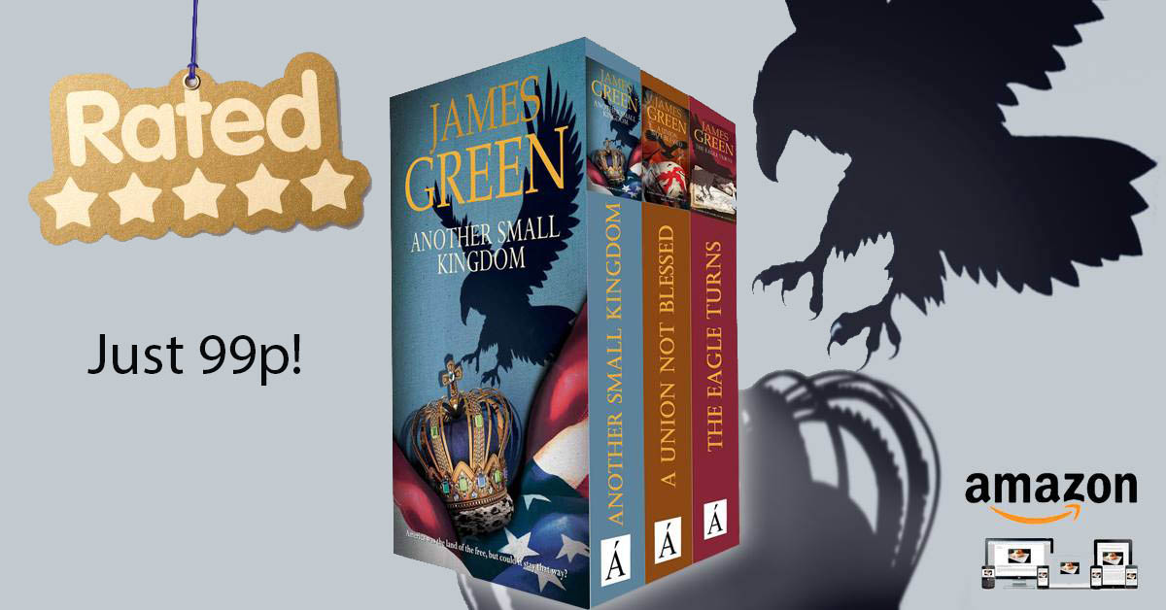

***The submissions window for the January 2019 issue* is now open for articles, reviews, letters…in fact anything you like including Adverts for anything you’ve published recently or long ago.***

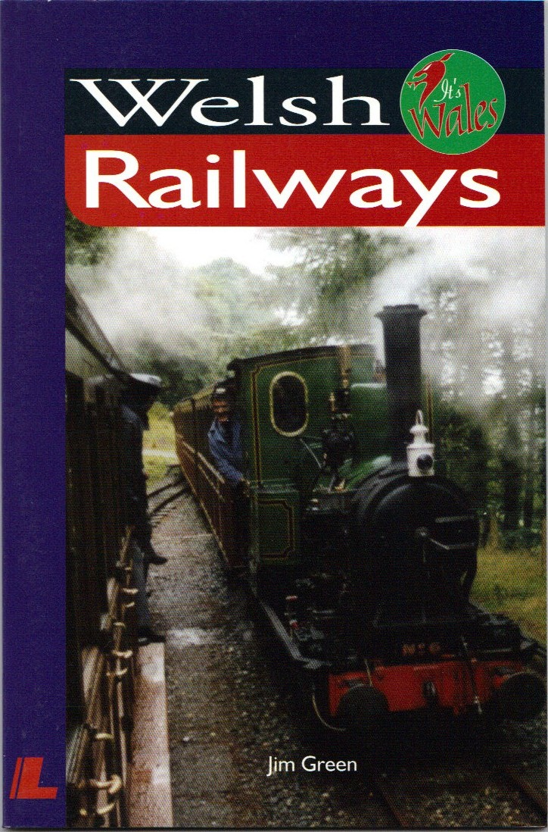

***Not only did Pat & I write the book, I took the photos!***

* *this is NOT a firm date so don’t hurry.*



Are you sitting comfortably?

**By Frances Kay**

***Shortly after Mark's diagnosis of Parkinson's, various adjustments in the home had to be made. In terms of safety and comfort, one of these was getting him a decent sized, solid armchair for the sitting room….***

Brrrr brrrrr ….. brrrr brrrr…… “Hello?”

“Hi Mum” came Emma's familiar voice down the phone one evening, “can you do me a favour?”

“Of course, darling, what is it?” I answered.

“On my way home after seeing you today I popped into that nice home furnishing store in the shopping centre and found a large brown leather armchair in their sale. It’s the perfect thing for Dad and an amazing bargain, only £350. They’ve marked it ‘sold’ for me and are holding it for 24 hours. I'll transfer the money into your account tomorrow, if you could you pop into the shop in the morning, give them the money and arrange delivery to you?”

“Oh, how kind. Thanks darling, will do.” I replied.

So the mission is 'schimples', as the meercats might say. Go to shop, confirm daughter’s purchase of said chair, pay for it and give delivery instructions to our home. Early next morning, I walk over to the shopping precinct. Shortly after the doors open I approach the Customer Services Desk and catch the eye of a somewhat reluctant Customer Services Assistant (CSA). She is busy doing something definitely not work-related and looks at me with suspicion as I am clearly about to interrupt her.

***…looks on in horror as if I'm producing a rattlesnake….***

Me: Good morning, I’ve come to buy that chair. (The brown leather armchair is winking at her from behind the counter).

CSA: Sorry, you can’t. As you can see, it's marked 'sold'.

Me: Yes I know, my daughter bought it.

CSA: And I said that you can’t buy it. It's been purchased and it's the only one we have.

Me: No, I don’t wish to buy it, merely pay for it on behalf of my daughter, who isn’t here.

CSA: You can’t do that if you’re not the purchaser.

Me: Yes, I know, as I’ve said, the purchaser is my daughter who can’t be here. I just want to give you the money for it.

CSA: And I’ve said that's not possible if you're not the purchaser.

Me: I'm sorry, I don’t understand.

CSA: If you don't understand I’m going to have to call my Supervisor.

Me: Oh what a good idea, as we don't seem to be making much progress here.

CSA picks up intercom to Supervisor: I've got someone here who wants to buy a chair that’s already sold.

Supervisor: Ask who she is and where she lives.

CSA: Who are you and where do you live?

Me: I’m Frances Kay. I live at 20 College Street, Gloucester and I wish to pay for that chair.

CSA repeats this and listens to supervisor’s response. She turns to me: Well, you can’t. My supervisor says the person buying that chair has a different name and lives in Portsmouth.

Me (sighing): Yes, Mrs Emma Barfoot who lives in Portsmouth, is my daughter. She was in this shop yesterday, saw the chair, thought it would be the perfect thing for her father and said she’d buy it. It was nearly closing time, she didn’t have cash with her, or her credit card. She promised she’d pay for it this morning if you'd hold it for her. She's now back in Portsmouth. I am here to pay for the chair in cash. Can you help me?

CSA (with a suspicious glance in my direction): It says here ‘To be Delivered’. We don’t deliver as far as Portsmouth.

Me: Fine, that's not a problem. We don't need it delivered to Portsmouth, I live in Gloucester. My daughter wants it delivered to me.

CSA: But you’re not buying the chair, so we can’t deliver it to you. Anyway, it’s already sold. It’s marked for Mrs Barfoot. She lives in Portsmouth and I’ve told you we don’t deliver to Portsmouth.

Me, speaking very slowly and clearly: Yes, I know, and I have the money here from Mrs Barfoot to pay for the chair. She has bought it as a present for her father. And look, here is the money to pay for it ……..(slowly produce cash from my pocket and count out notes in front of CSA). CSA looks on in horror as if I'm producing a rattlesnake….

CSA (now furious at being unable to foil my dastardly plan to buy the chair): Well, if you are paying for the chair and want it delivered, you’ll have to fill out this form.

Me: Fine, thank you. If you take the money and give me a receipt. I’ll fill out the delivery form.

I'm then handed a form with 23 questions on it – it runs to three pages. The CSA at this point is hanging grimly to the hope that I'll be so flummoxed that I won’t be able to cope with the paperwork. Baffled at the complexity of the questionnaire, I wonder what the store think customers are trying to do? Apply for a job at GCHQ or give delivery instructions for an item of furniture? Minutes pass, I complete the form, the reluctant CSA gives me a receipt for the money and takes the paperwork away.

Some of the questions were curious to say the least. Apart from the obvious: name, address, postcode, contact number, it was necessary to describe what sort of house we live in, did we have a staircase leading up to our front door, was it our own home or was it used by other people, what sort of floor covering did we have, would this represent a health and safety hazard to the delivery men entering the premises, were there any steps from front door to where item of furniture was being delivered, and were there any dangerous animals on the premises (if so, what breed and how many) or toxic substances the delivery men might come into contact with on entering the dwelling……. Clearly in this city delivery men are an endangered species and must be taken great care of.

At this point I said if it’s too much trouble for the delivery man to cope with, if he could just get the chair as far as the front garden I'd then take responsibility for carrying it inside the house. CSA writes something inside box labelled “special instructions” probably “Very Difficult Customer…..”.

I arrange a convenient time for the man to attempt to deliver chair, and leave shop wearily. It’s now almost 10 am. Surely it must be time for a sit- down….? As I wander home I muse on how curious it is that some people spend much of their working lives doing something they hate or are perhaps temperamentally unsuited for.

