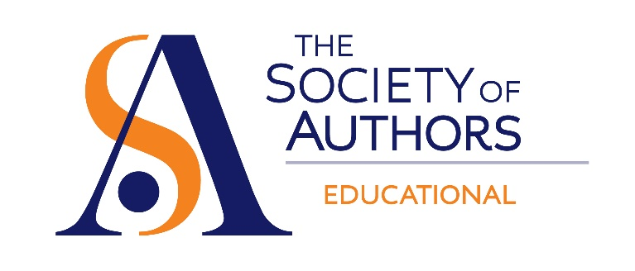
Welcome to the Educational Writers Group 2019 AGM.

A few statistics for you first:
There are currently 887 members of the Educational Writers Group. Overall, we gained 66 members and lost 53. The SoA’s current total membership is 10858, so EWG represents 8.17%.

AWARDS FOR EDUCATIONAL WRITING

The 2018 ALCS Award for Educational Writing was given to Cath Senker in December of last year for her title Far From Home, published by Franklin Watts. This award was set up to honour works of traditionally published non-fiction which enhance learning, and the 2018 prize recognised the 11-18 age group. Congratulations also to the authors of the shortlisted titles: Loos Saves Lives by Seren Boyd, How To Think Like A Coder by Jim Christian and illustrated by Paul Boston, From Prejudice to Pride by Amy Lamé and The Story Of Painting, written and illustrated by Mick Manning and Brita Granström.
We are grateful to the Authors’ Licensing and Collecting Society for their generous sponsorship.

The EWG award for Editorial Best Practice was launched in October 2018. This new award allows members to publicly recognise those editors who have shown excellence in the way in which they have collaborated with their authors. So far two editors have received the award. Collins Learning Editor Lucy Cooper was nominated by Libby Mitchell for her work on the Collins IGCSE Spanish Student’s Book. Wayland Editor Nicola Edwards was nominated by Annemarie Young for her work on What is Right and Wrong? Who decides? Where do Values come from? And other Big Questions (co-authored with Michael Rosen).
More details, including how to nominate, can be found on the EWG section of the website.

EWG ACTIVITIES

The 2018 EWG seminar day was held on 9 June. Around 35 authors attended the day, which had parallel sessions, six speakers and plenty of opportunities to network. Several more authors joined the sessions via the live audio-stream. Topics included: the importance of textbooks, writing Graded Readers, generating income from online courses and the author-editor relationship.
The EWG quarterly e-newsletter keeps members up to date with the Group’s activities and industry news. In the past eighteen months, many of the Group’s members have provided blogs on topics which are of particular interest to those working in this sector, and the regular interview slot has allowed members to gain an appreciation for the wider community of educational writers. The Group also has a dedicated, private discussion page on Facebook, open only to those who are currently members of the SoA.
If you would like to contribute to a future newsletter, or are interested in joining the Facebook group, please contact Group Secretary Bryony Hall.

OFSTED CONSULTATION

The EWG Committee provided feedback for the SoA’s response to Ofsted’s consultation on its new draft inspection framework earlier this year. The draft framework sets out plans to place new emphasis on ‘substance of education’ and to include a new ‘quality of education’ judgement in inspections.
The SoA believes that in recent years the curriculum and Ofsted’s approach has been too focused on exams at the expense of a well-rounded education that encourages interest in learning and develops creativity. As such, the new emphasis on examining the overall breadth and quality of education is welcome.
The SoA’s full response to the consultation can be found on the website.

QUALITY ASSURANCE FOR TEXTBOOKS

In September 2018 there were reports in the trade press that the government was considering introducing a quality assurance scheme for school textbooks. The EWG committee raised some key concerns with this proposal, including the introduction of unnecessary government interference in classrooms, and the negative effect the scheme might have on the provision of materials for less confident learners and readers. These concerns were set out in a letter from the SoA to the Department for Education. The SoA has received assurances from the DfE that the government is not currently proceeding with a kitemark scheme. The Secretary has arranged to speak to a representative from the department every few months to discuss any developments.

COMMITTEE NOMINATIONS

Thanks to all our committee members for their hard work over the last eighteen months. Special thanks go to Chris Barker and Peter Clarke, who are leaving the committee having completed their term.
Our three nominees to join the Committee this year are Philippa Gardom Hulme, Sue Nicholson and Chitra Soundar. There were no alternative nominations, and we welcome them to the committee for a period of three years. They join Sarah Ackroyd, Ignaty Dyakov, Terry Freedman, Mark Griffiths and Julie Pratten. I will be stepping down as chair and handing over to Ignaty.

That concludes my report. Thank you all for your support this year.

Anne Rooney (Outgoing Chair)

8 June 2019

